[Series 4 Paper 1 Title]

Alice E. Williamson, Thomas Macdonald, Joanna Ubels, Patrick Thompson, Peter J. Rutledge, Matthew H. Todd

[Abstract]

[Graphical Abstract]

[Background to Malaria]

[Discovery of Series 4 and subsequent development story]

Results and Discussion

**Synthetic Approaches to the TP Series**

[Summary of Organic Synthesis]

**Modification of the Triazolopyrazine Core**

Modification of the triazole ring was explored through the synthesis of the imidazo[1,2-a]pyrazine MMV669846 and the imidazo[1,5-a]pyrazine MMV670250 and comparison with the parent [1,2,4]triazole[4,3-a]pyrazine MMV639565 (Figure X). Such changes gave moderate decreases in potency (vs. PfNF54) and, particularly for MMV670250, a significant worsening in metabolic stability. The reasonable potency of MMV669846 suggests that the 2-position of this compound could be a point of attachment for functional groups (*e.g.,* biotinylated chains) that might assist in mechanism of action studies. The ring system in MMV669846 is the same as that in the similar-looking Novartis series based around KAI409,[10.1038/nature12782] but the mechanism of action of that compound targets PI4K and not PfATP4.

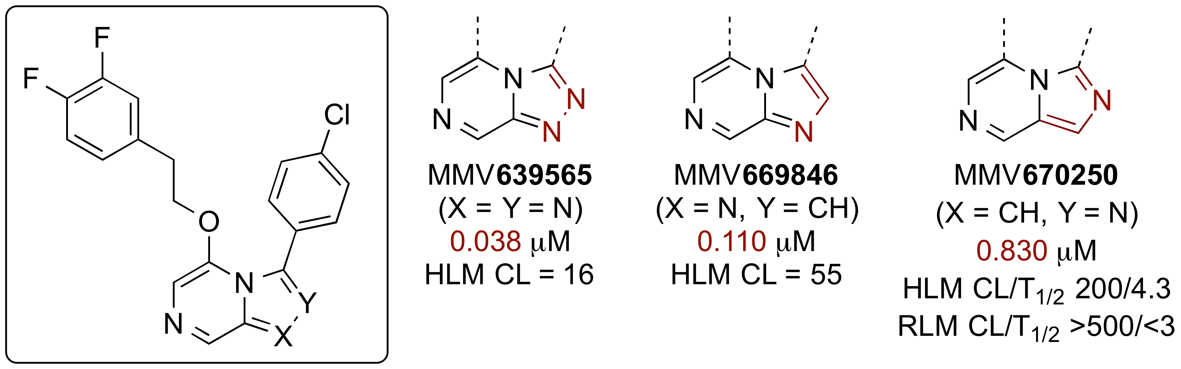

**Figure X**. Effect on Potency and Metabolic Stability of Altering the Triazole Portion of the Triazolopyrazine Core (Units)

Modifications to the pyrazine ring generally gave reductions in potency (Figure X) – several aromatic and aliphatic analogs have been evaluated. The transposed analog MMV672942 retained some activity (though the ether analog MMV672939 did not).

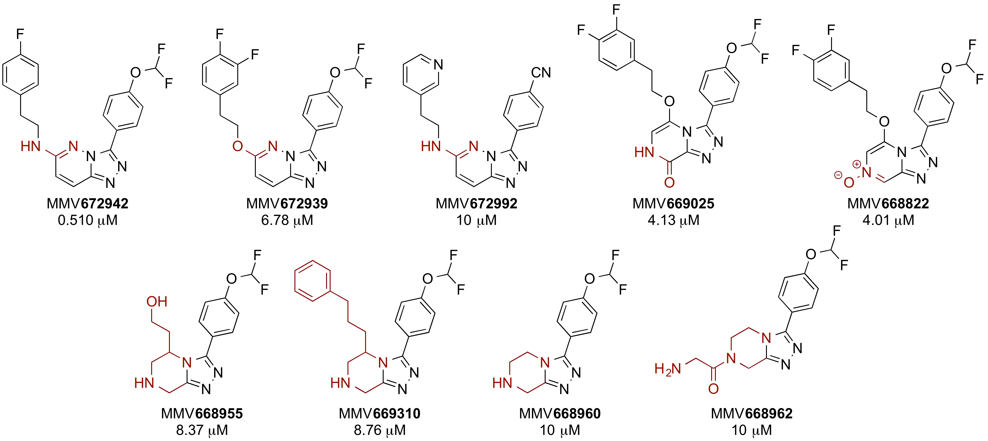

**Figure X**. Effect on Potency of Alterations in the Pyrazine Ring of the Triazolopyrazine Core.

**Modifications of the Triazolopyrazine Core Substituents**

With the triazolopyrazine scaffold established as the leading heterocyclic core for this series of compounds, variations were made in the substituents and their attachment pattern. Several compounds were evaluated bearing substitution in the 8-position (as a potential block for aldehyde oxidase activity, see below); only the analog possessing a reactiveα-chloro azaaromatic group (MMV668823) retained any significant potency. Analogs have not yet been evaluated with corresponding substituents in the 6-position. However, several compounds with transposed side chains were synthesized which in most cases exhibited reduced potency compared to closely related compounds lacking such a change. The exceptions were compounds containing ether-linked chains with a one-or two-carbon spacer, for example MMV670945 (though this compound displayed rapid metabolism in a rat liver microsome assay. In general substitution in the 5-position was prioritized for follow-up.

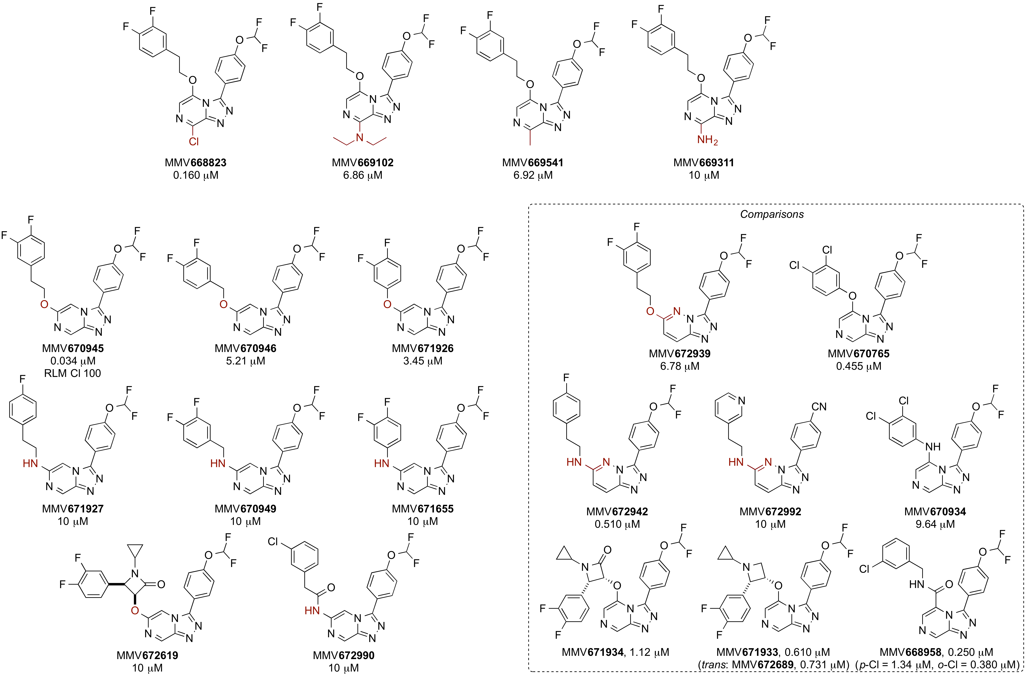

**Figure X**. Modifications to the Pyrazine Substituents and Comparisons with Closely Related Compounds (RLM Cl units are mL/min/kg)

Many compounds in this series displaying high potency possess aromatic substituents directly linked to the triazole ring in the TP core. Nine compounds were synthesized possessing aliphatic substituents in this position, or aromatic groups linked via a heteroatom, or a pyrazole. All exhibited greatly reduced potency compared to analogous compounds, though further exploration of aliphatic and heteroaromatic groups in this position remain a promising line of enquiry given that there is significant unexplored chemical space and that a reduction in the number of aromatic groups in the TP series should help increase compound solubility. However, priority was given to further optimization of aromatic functionality directly attached to the triazole in this position.

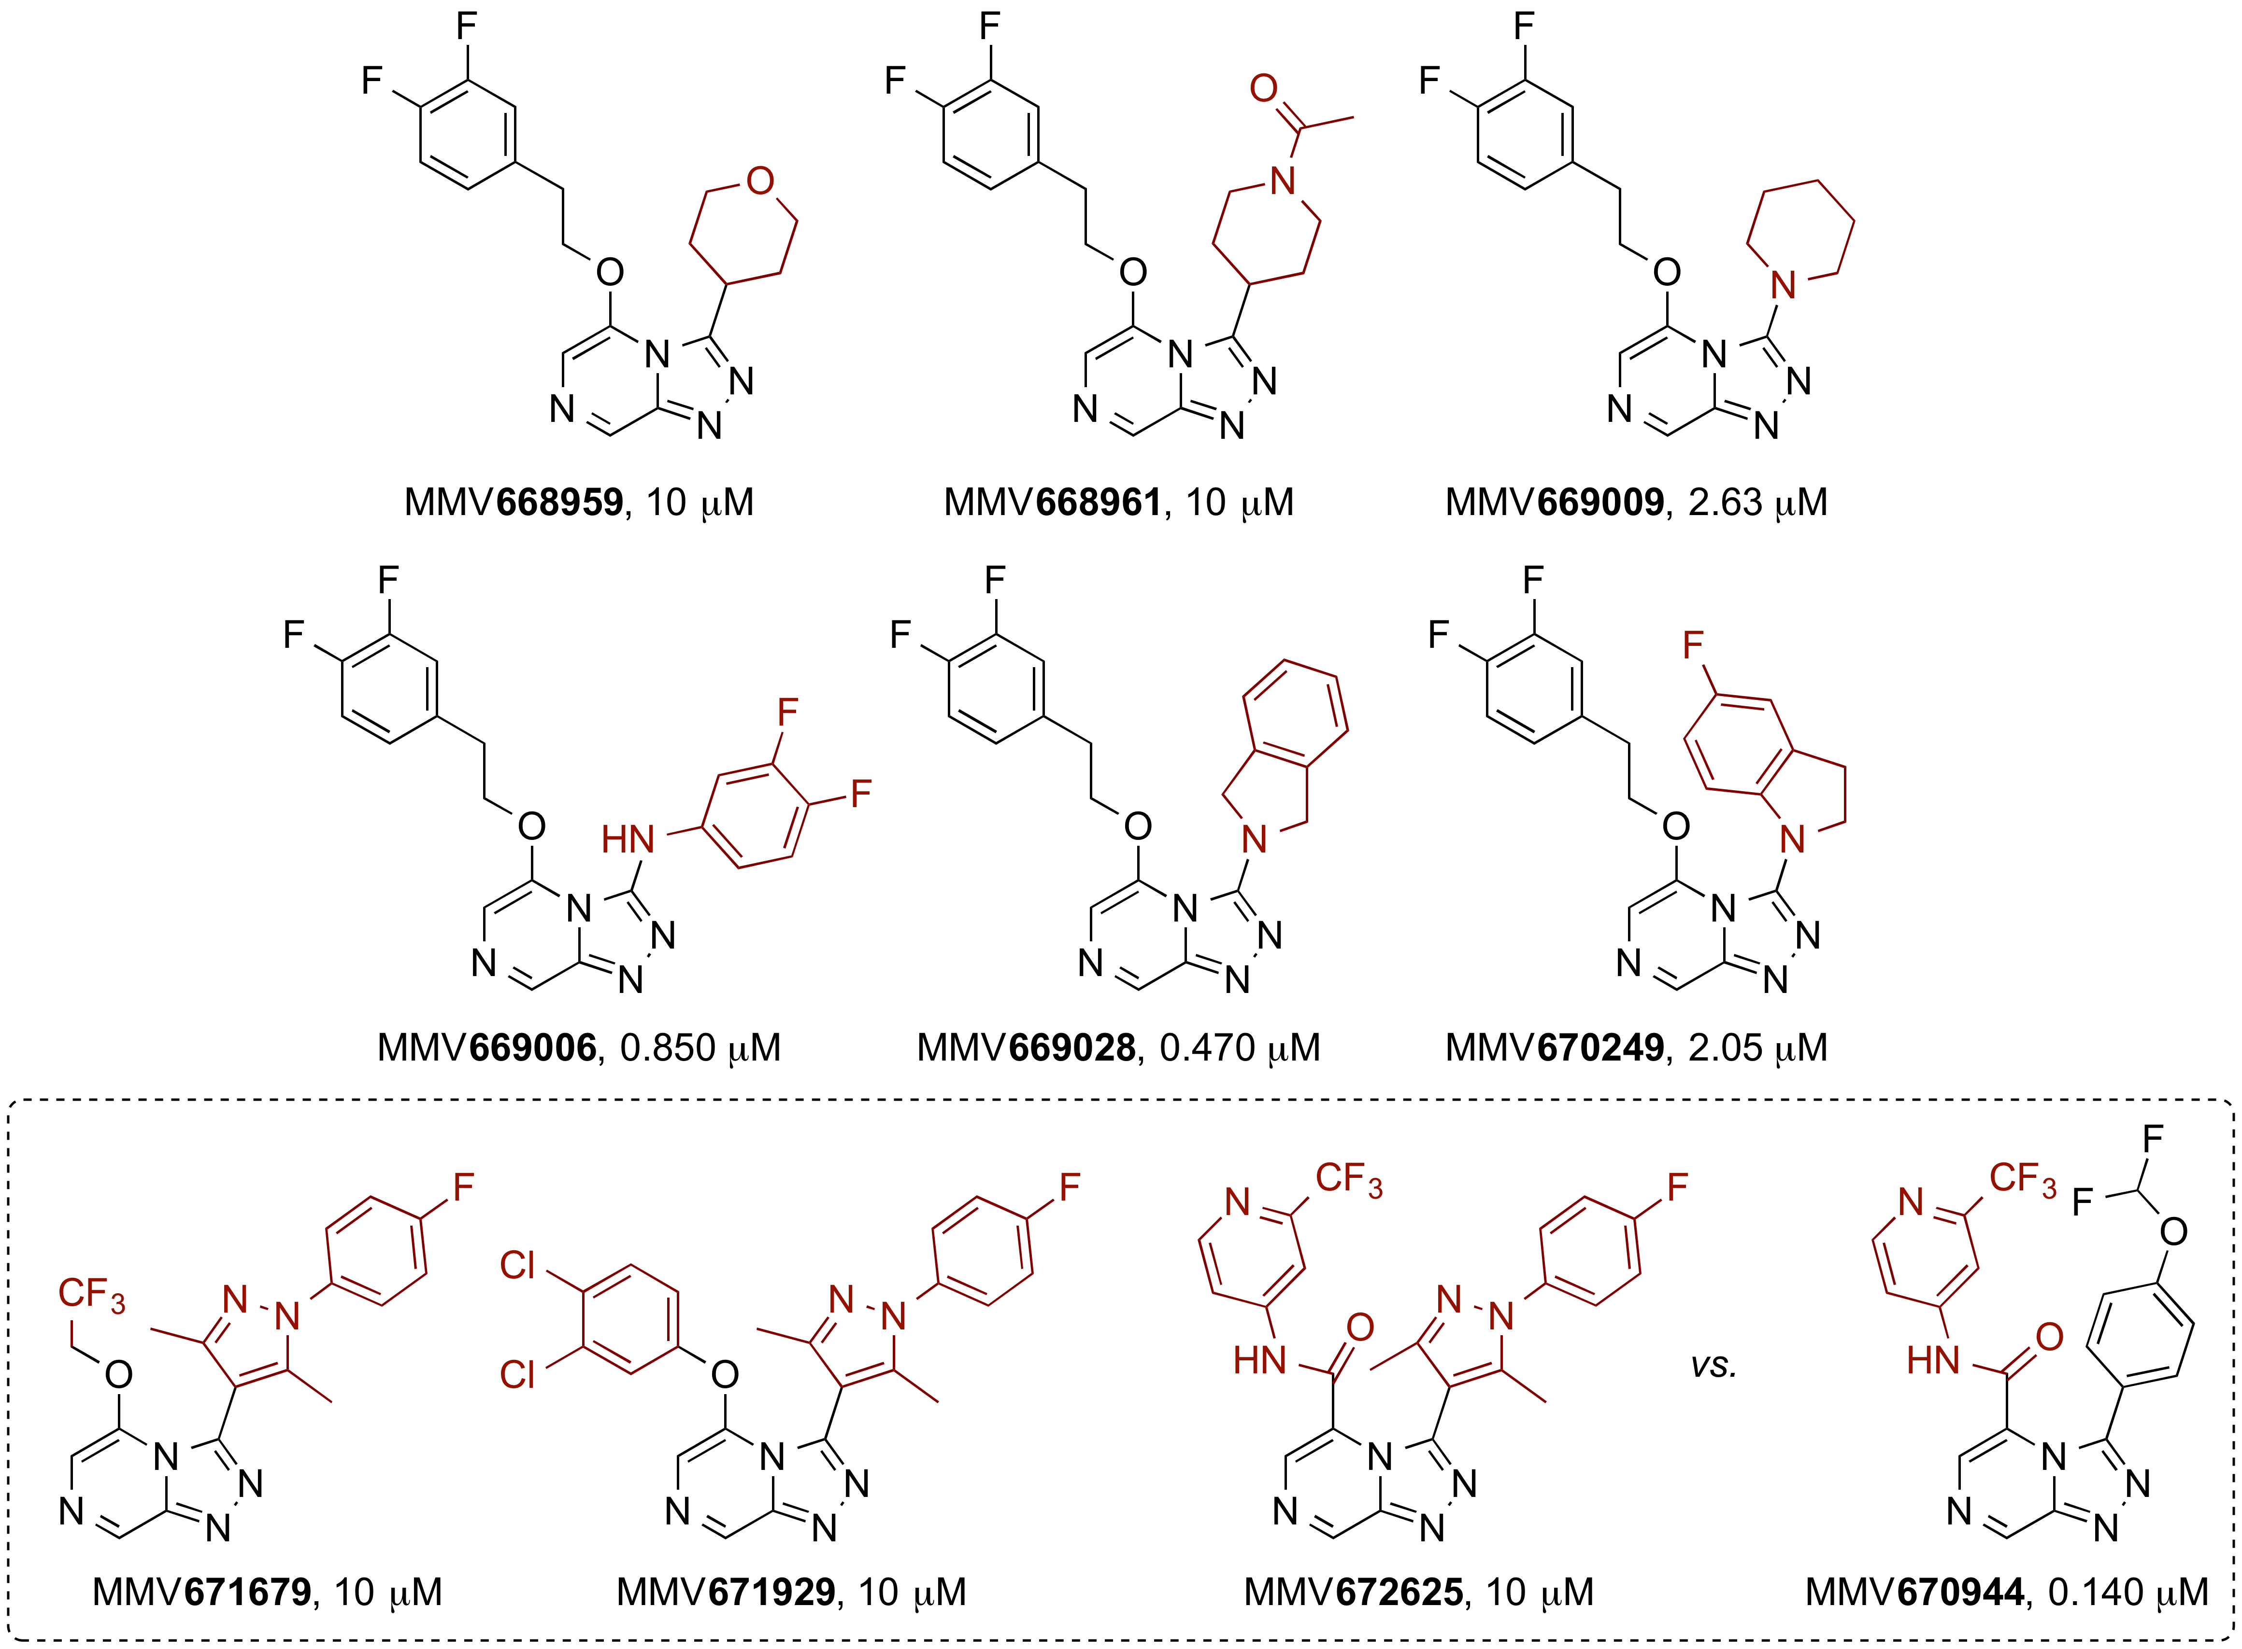

**Figure X**. Variation in the Structure of the Aromatic Substituent on the Triazole Ring of the TP Core.

**Variation in Ether-linked Substituent in the 5-Position**

Several analogs were explored with variation in the ether substituent at the 5-position, while retaining the 4-(difluoromethoxy)phenyl group directly attached to the triazole ring (Figure X). Potent compounds were observed with phenethylether side chains, but given the propensity for such compounds to act as metabolic hotspots significant variation was explored in the structure of this substituent. In general a range of variations was tolerated, including those with polar functional groups in the benzylic position (of note is the alcohol MMV670947 at 24 nM and the amine MMV670437 at 44 nM). The primary amine analog of MMV670437 (MMV671651) remained potent (as did the morpholine analog MMV671647 to a lesser extent), while the monomethyl analog MMV670763 exhibited greatly reduced potency. A single analog with substitution on both carbon atoms of the phenethyl methylenes (MMV672626) exhibited low potency. Side chain lengths other than three atoms generally gave lower potencies. The 2-naphthol analog MMV670659 gave reasonable potency but poor stability in a rat liver microsome assay (we lack the number). While not potent the phenol-substituted analog MMV669784 exhibited favourable metabolic clearance rates (see below).



**Figure X**. Measured Potencies of TP Analogs with 4-(CHF2)O-phenyl Attached Directly to the Triazole Ring with Variation in the Ether Substituent in the 5-Position (Assay for OSM-S-260 possibly different from others)

A corresponding set of amides in the 5-position was investigated where the 4-(CHF2)O-phenyl was once again held constant as the attachment on the triazole ring and the amide was connected to the TP core via the carbonyl carbon (Figure X). Several compounds showed promising levels of potency, principally those with amides synthesized from anilines and benzylanilines, though there was found to be very high sensitivity of the potency on the substitution pattern of the pendant aromatic ring. Several compounds that contained amides made with aliphatic or tertiary amines were found to be inactive. A range of these amides were assessed for their metabolic stability (see below). Reproducibility between assays was addressed in this set via resynthesis of MMV669542, an inherited compound that was originally found to possess a potency of 180 nM and for which the resynthesized compound (OSM-S-202) gave a potency, in a different laboratory to that providing the original data, of 242 nM.

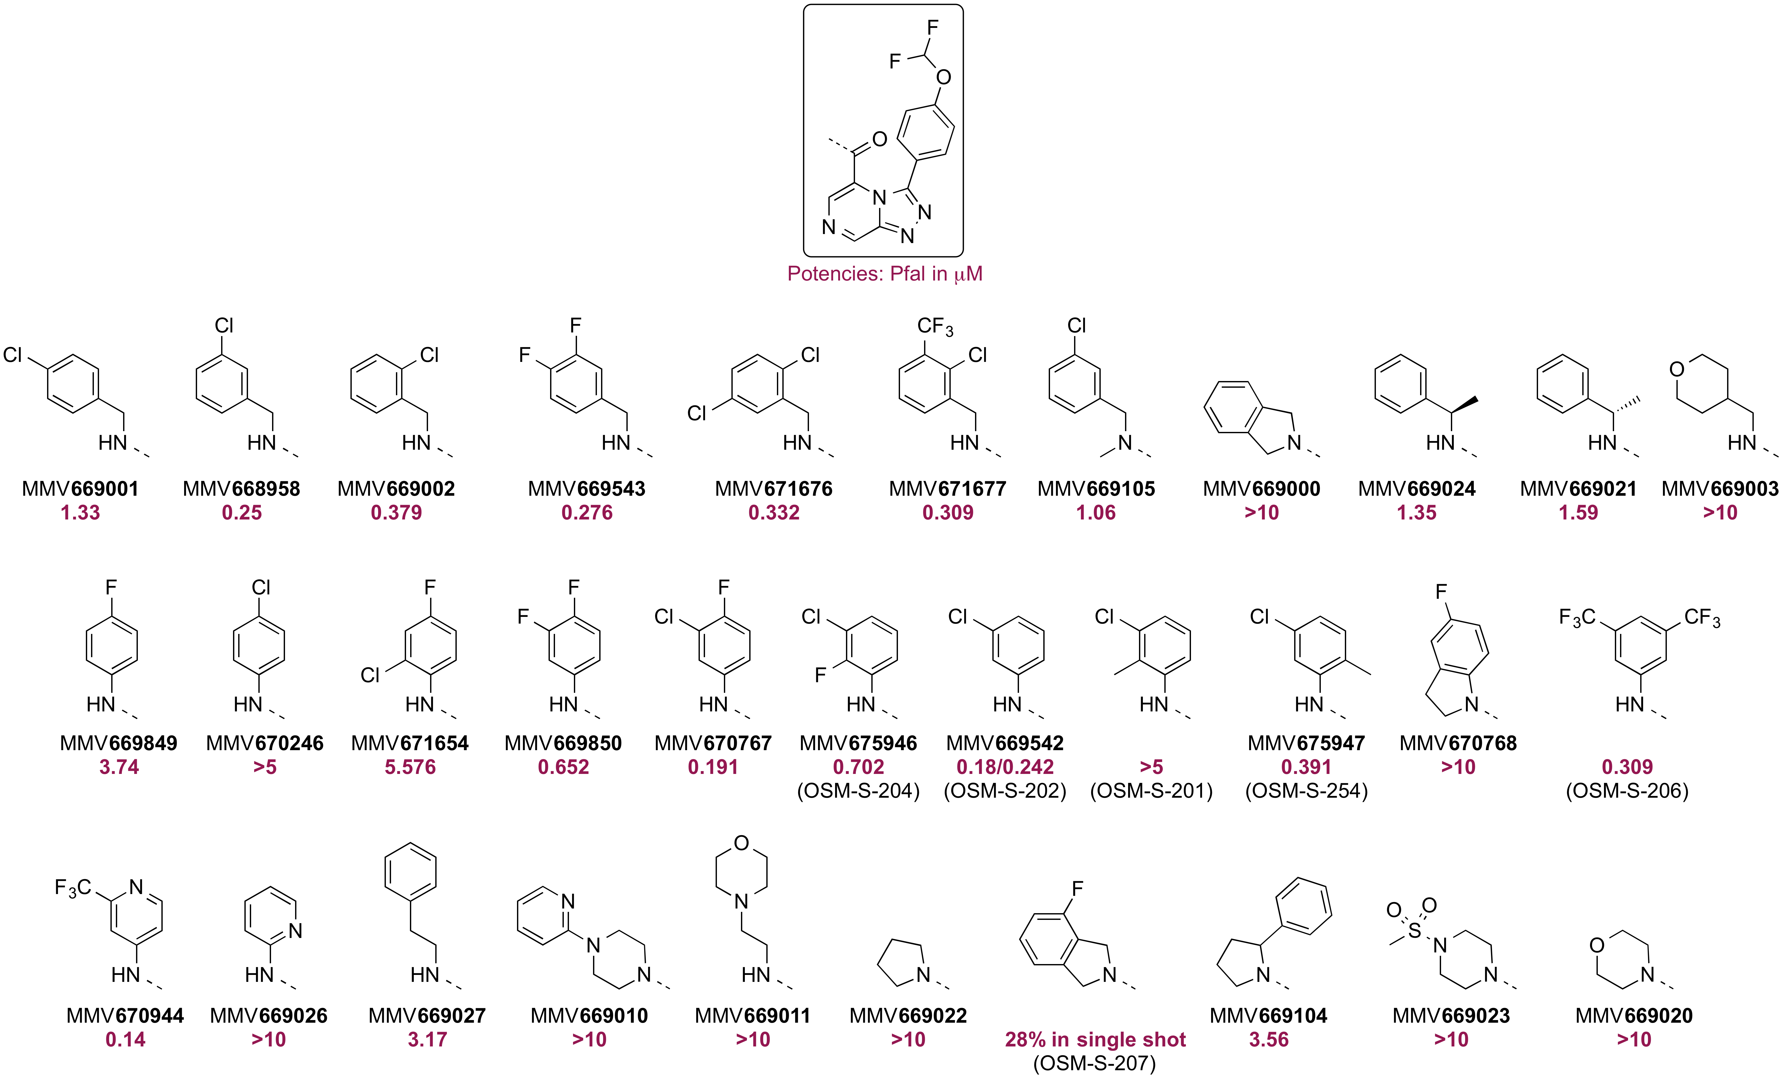

**Figure X**. Measured Potencies of TP Analogs with 4-(CHF2)O-phenyl Attached Directly to the Triazole Ring with Variation in the Amide Substituent in the 5-Position

Again holding the triazole aromatic substituent constant a number of other substitutions were explored at the 5-position, including amines, azaaromatics, sulfonamides and carbon-based aliphatic linkers (Figure X). With the exception of one or two carbon-based linking strategies (notably MMV669848) all compounds were found to exhibit low potencies.

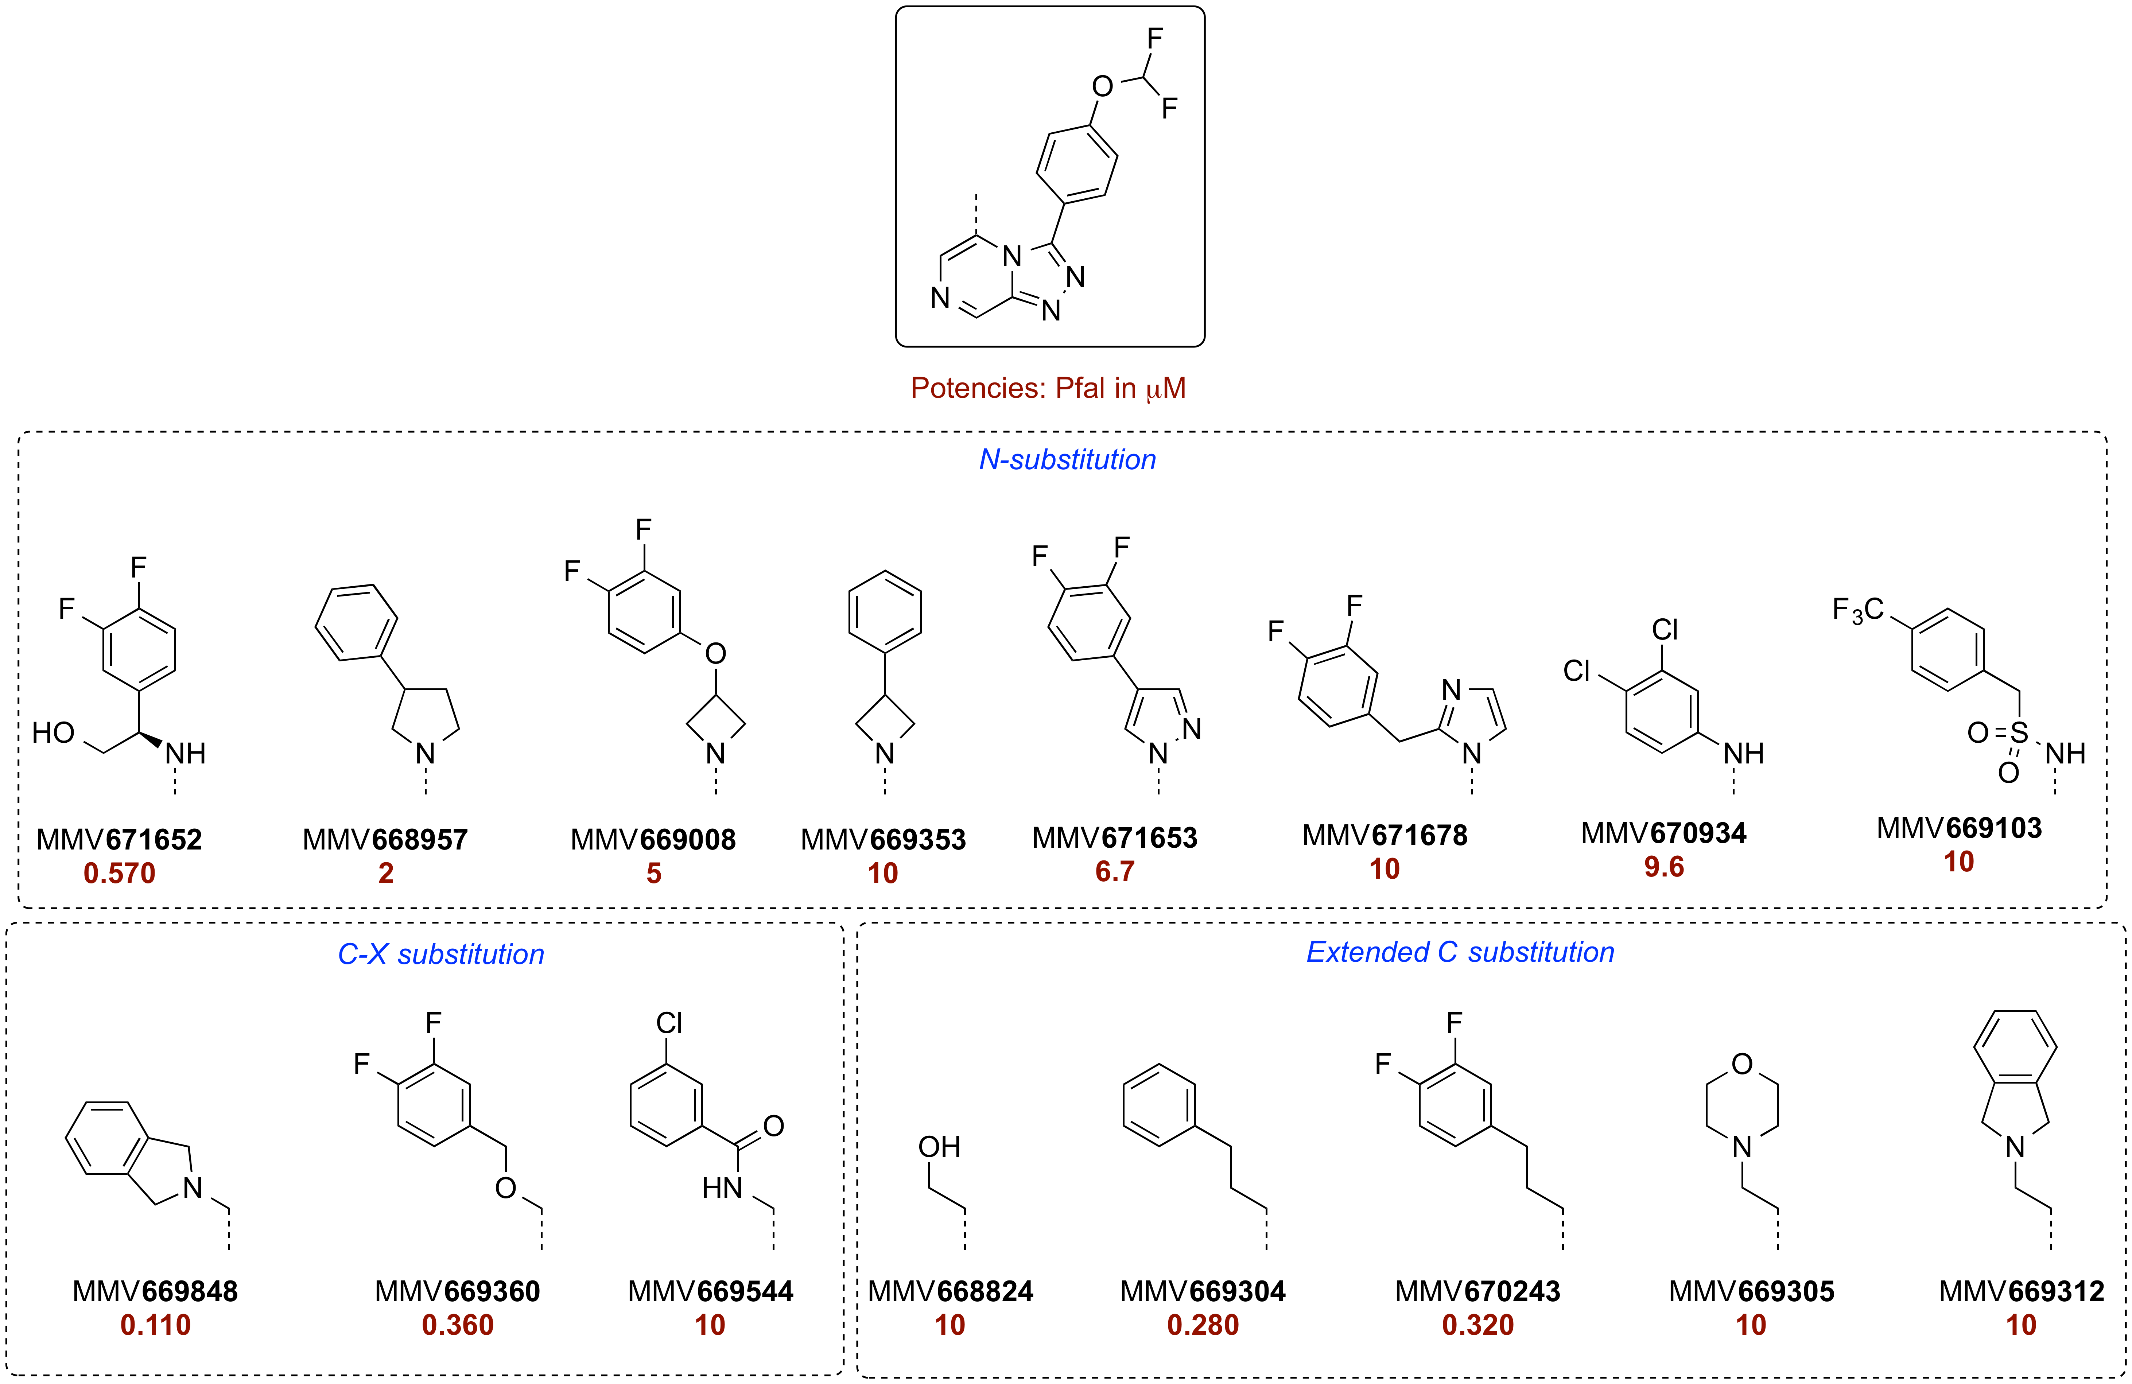

**Figure X**. Measured Potencies of TP Analogs with 4-(CHF2)O-phenyl Attached Directly to the Triazole Ring with Variation in the Linker Connecting the Substituent in the 5-Position

Finally, further minor modifications were made to the aromatic moiety attached to the triazole ring, while employing various substituents on the pyrazine ring (Figure X). Examples of the substitution of 4-(OCHF2) on the phenyl ring in this position for 4-Cl (*e.g.,* MMV639565) and 4-CN (e.g., MMV672992) have been seen above. The other examples indicate that excellent levels of potency can be achieved with 4-CN substitution (*e.g.,* MMV670652, which also contains a benzylic difluoromethylether). Linkage of the pendant aromatic group to the 5-position via thioether or amine linkers essentially eliminated activity. The predicted solubility for TP analogs with various 4-substituents on the triazole aromatic ring is in the order CN>CHF2>Cl but in general these analogs are predicted to possess low solubility (CLogP ranging from 3.6 to 4.9). Given the favourable potency found for MMV670936, analogs with a simple pyridine ring attached to the triazole (cLogP ranging from 3.5 to 2.6) were evaluated but found to be inactive; substituted pyridines in this position remain a high value target. The replacement of OCHF2 with the more synthetically convenient OCH3 gave compounds of significantly reduced potency, but OCF3 (in MMV675963/OSM-S-271) was tolerated as a replacement in this position (compare OSM-S-202, at 0.242 μM).

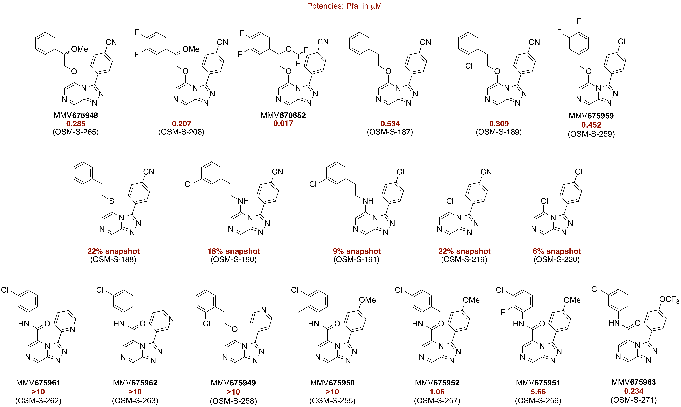

**Figure X**. Variation in the Aromatic Substituent Attached to the Triazole Ring of Various TP Analogs

**Metabolic Stability**

References

Burkhard JA, Wuitschik G, Rogers-Evans M, Mueller K, Carreira EM (2010) Oxetanes as versatile elements in drug discovery and synthesis. Angew Chem Int Ed 49: 9052–9067 (10.1002/anie.200907155)